**YARD DUTY AND SUPERVISION POLICY**

**Purpose**

To ensure school staff understand their supervision and yard duty responsibilities.

**Scope**

The principal is responsible for ensuring that there is a well-organised and responsive system of supervision in place during school hours, before and after school, and on school excursions and camps.

This policy applies to all teaching and non-teaching staff at Castlemaine Primary School, including education support staff, casual relief teachers and visiting teachers.

School staff are responsible for following reasonable and lawful instructions from the principal, including instructions to provide supervision to students at specific dates, time and places.

**Policy**

### **Before and after school**

Castlemaine Primary School’s grounds are supervised by school staff from **8.35 am until 3.35 pm.** Outside of these hours, school staff will not be available to supervise students.

**Outside school hours supervision & care**

Parents and carers should not allow their children to attend Castlemaine Primary School outside of the designated supervision times. Families are encouraged to contact **Bendigo YMCA** for information about the before and after school care facilities available to our school community.

If a student arrives at school before supervision commences at the beginning of the day, the principal or nominee staff member will, as soon as practicable, follow up with the parent/carer to:

* advise of the supervision arrangements before school
* request that the parent/ carer make alternate arrangements

If a student is not collected before supervision finishes at the end of the day, the principal or nominee staff member will consider whether it is appropriate to:

1. attempt to contact the parents/carers
2. attempt to contact the emergency contacts
3. place the student in an out of school hours care program (if available)
4. contact Victoria Police and/or the Department of Health and Human Services (Child Protection) to arrange for the supervision, care and protection of the student.

School staff who are rostered on for before or after school supervision must follow the processes outlined below.

### **Yard duty**

All staff at Castlemaine Primary School will assist with yard duty supervision and will be included in the weekly roster.

The principal is responsible for preparing and communicating the yard duty roster on a regular basis. At Castlemaine Primary School, school staff will be designated a specific yard duty area to supervise.

The designated yard duty areas for our school are indicated below:

|  |  |
| --- | --- |
| **Zone** | **Area** |
| Zone 1 | Oval, Playground, Basketball court |
| Zone 2 | Area behind buildings, upper asphalt area, decking, toilets |

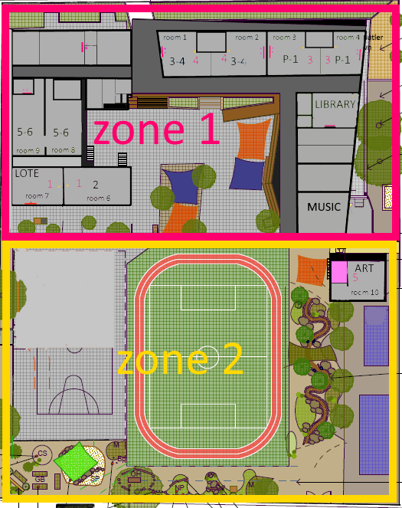

School staff must wear a provided safety/hi-vis vest whilst on yard duty. Safety/hi-vis vests will be stored the staff room.

Staff who are rostered for yard duty must remain in the designated area until they are replaced by a relieving teacher.

**During yard duty, supervising staff must:**

* Staff must actively move around the designated zone
* Staff should not congregate in one area only. This cannot constitute effective supervision of the yard
* be alert and vigilant
* intervene immediately if potentially dangerous or inappropriate behaviour is observed in the yard
* enforce behavioural standards and implement appropriate consequences for breaches of safety rules, in accordance with any relevant disciplinary measures set out in your school’s *Student* *Engagement and Wellbeing* policy
* ensure that students who require first aid assistance receive it as soon as practicable
* log any incidents or near misses as appropriate on Compass
* if being relieved of their yard duty shift by another staff member, ensure that a brief but adequate verbal ‘handover’ is given to the next staff member in relation to any issues which may have arisen during the first shift

If the supervising staff member is unable to conduct yard duty at the designated time, they shouldcontact the Principalwith as much notice as possible prior to the relevant yard duty shiftto ensure that alternative arrangements are made.

If the supervising staff member needs to leave yard duty during the allocated time, they should contact the Principalbut should not leave the designated area until the relieving staff member has arrived in the designated area.

If a relieving or next staff member does not arrive for yard duty, the staff member currently on duty should remain on duty and not leave the designated area until a replacement staff member has arrived. A senior student can be sent to the office to notify another staff member.

Should students require assistance during recess or lunchtime, they are encouraged to speak to the supervising yard duty staff member.

### **Classroom**

The classroom teacher is responsible for the supervision of all students in their care during class.

If a teacher needs to leave the classroom unattended at any time during a lesson, they should first contact the office or another staff member for assistance. The teacher should then wait until another staff member has arrived at the classroom to supervise the class prior to leaving.

### **School activities, camps and excursions**

The principal and leadership team are responsible for ensuring that students are appropriately supervised during all school activities, camps and excursions. Appropriate supervision will be planned for special school activities, camps and excursions on an individual basis, depending on the activities to be undertaken and the level of potential risk involved.

**Further Information and Resources**

* School Policy and Advisory Guide:
  + [Supervision](http://www.education.vic.gov.au/school/principals/spag/safety/pages/supervision.aspx)
  + [Duty of Care](http://www.education.vic.gov.au/school/principals/spag/safety/Pages/dutyofcare.aspx)
  + [Child Safe Standards](http://www.education.vic.gov.au/school/principals/spag/safety/Pages/childsafestandards.aspx)
  + [Visitors in Schools](http://www.education.vic.gov.au/school/principals/spag/safety/Pages/visitorsinschool.aspx)

## **Review Cycle**

This policy was updated on 14th November 2018 and is scheduled for review: November 2020. This policy will also be updated if significant changes are made to school grounds that require a revision of Castlemaine Primary School’s Yard Duty and Supervision Policy.